**1: GIT-HOL**

**Step 1: Setup Git Configuration**

1. Open Git Bash and check if Git is installed:  
 Command: git –version  
2. Configure Git with your username and email:  
 Command: git config --global user.name "lohith"  
 Command: git config --global user.email “shankarmatcha1979@gmail.com”   
3. Verify the configuration:  
 Command: git config --global –list

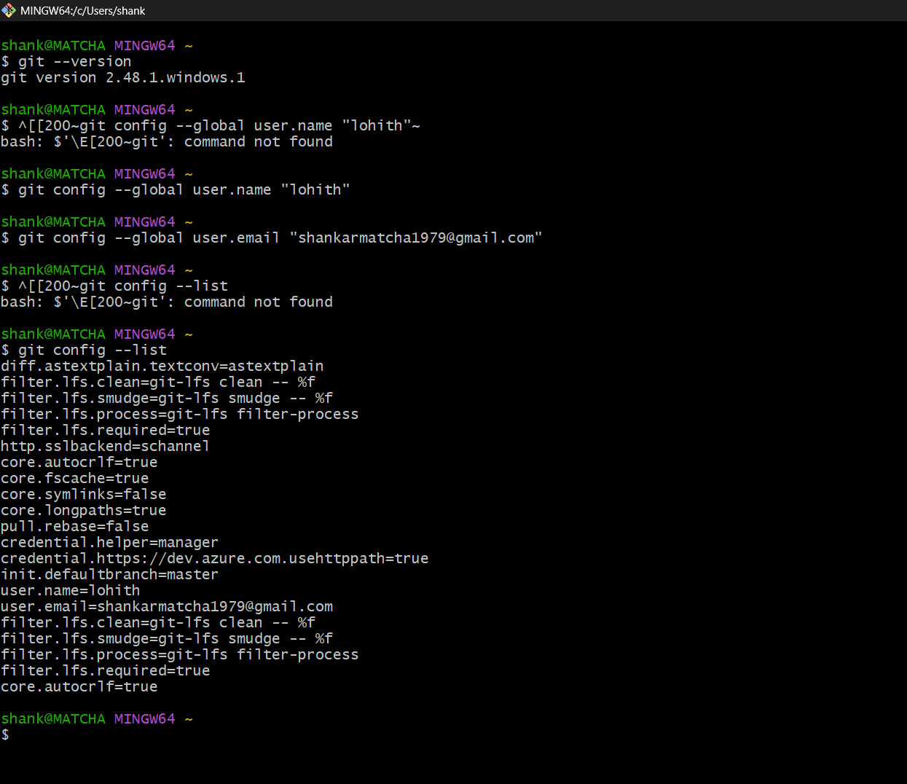

**Step 2: Set Notepad as Git Default Editor**

1. In Git Bash, set Notepad as the default editor:  
 Command: git config --global core.editor "notepad"  
2. Test if it's set correctly:  
 Command: git config --global –edit

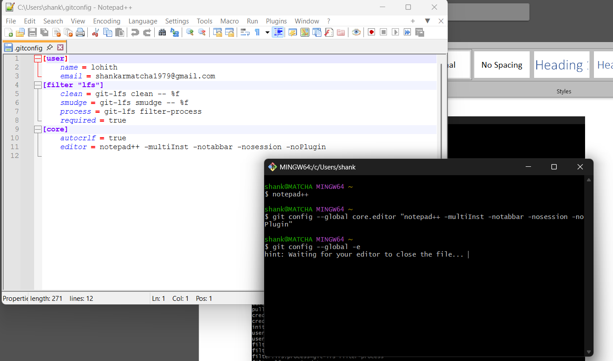

**Step 3: Create Local Git Repository**

1. Create a project folder and initialize Git:  
 Command: mkdir GitDemo  
 Command: cd GitDemo  
 Command: git init

2. Verify Git initialization:  
 Command: ls -a  
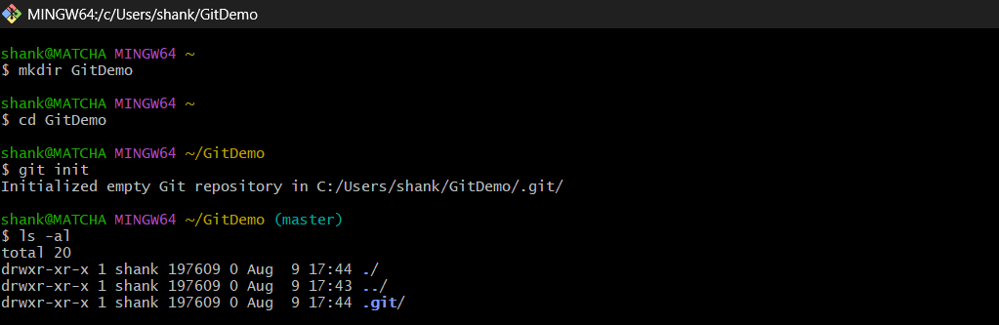

**Step 4: Create and Add a File**

1. Create a file named Welcome.txt:  
 Command: echo "Welcome to Git Hands-on Lab!" > Welcome.txt  
2. Verify file creation:  
 Command: ls  
 Command: cat Welcome.txt

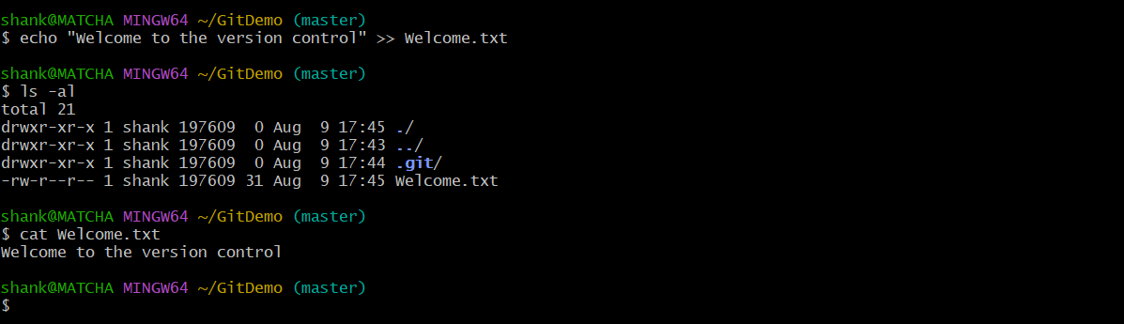

3. Check Git status:  
 Command: git status

4. Stage the file:  
 Command: git add welcome.txt  
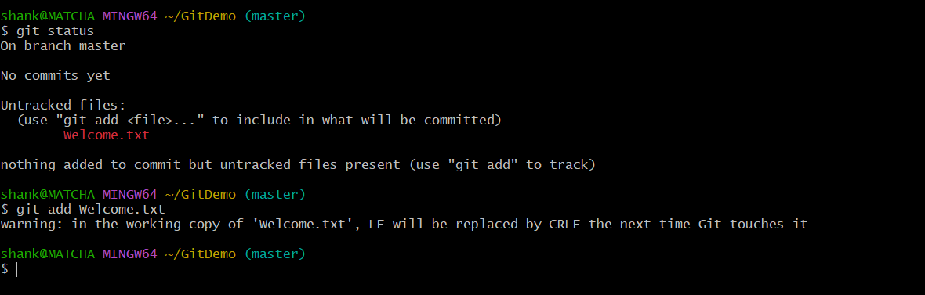  
5. Commit the file:  
 Command: git commit  
 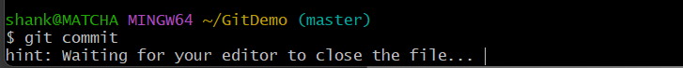 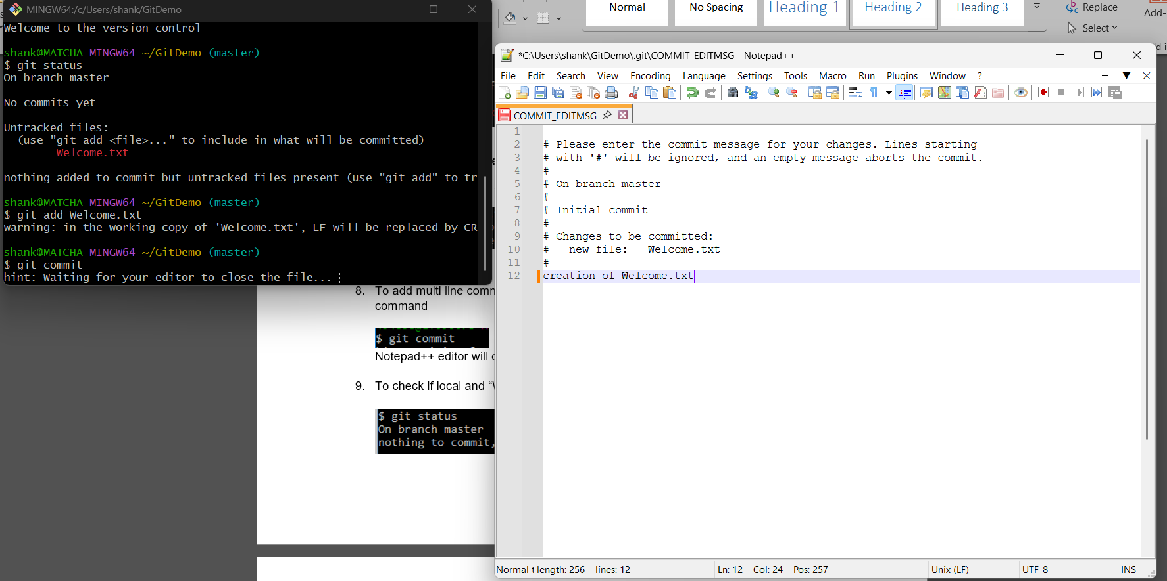  
  
6. Check status again:  
 Command: git status  
  
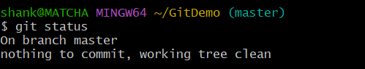

**Step 5: Connect to Remote Repository (GitLab)**

1. Login to GitLab and create a new project named GitDemo.  
  
2. Link the remote repository:  
 Command: git remote add origin <https://gitlab.com/lohithmatcha/GitDemo.git>

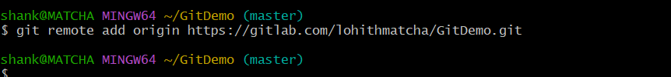  
  
4. Push your local commit:  
 Command: git push -u origin master

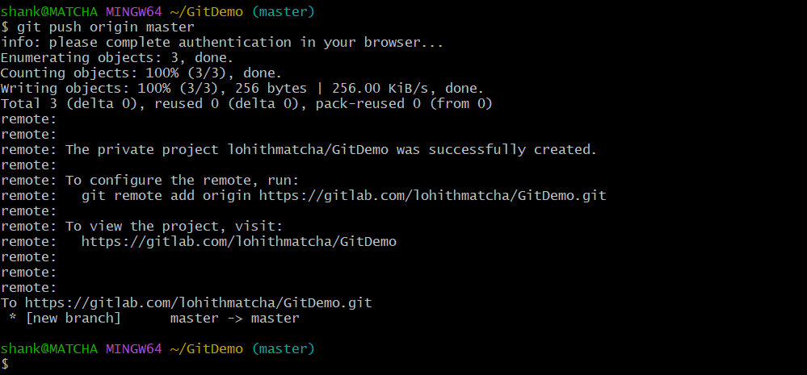

Click on below link to open in gitlab

<https://gitlab.com/lohithmatcha/GitDemo.git>